Quarterly Report

January – March 2019

Development Action for Mobilization and EmancipatioN

مضبوط عورت مضبوط معاشرہ

“No nation can rise to the height of glory unless women are side by side with men”

(M. Ali Jinnah)

- 3,443 Students Enrolled in 96 Home Schools
- 1,614 Patients Visited 12 Health Centers
- 497 Patients Visited 12 LHV Health Camps by SO
- 1,113 Patients Visited 12 Medical Health Camps organized by DAMEN for DSP
- 293 Women Attended 6 Women Social Organization (WSO) Meetings arranged by DAMEN for DSP
- 3,311 Women Attended 239 WSO Meetings Conducted by Social Organizers on Community Issues

Abstract:
The current quarterly report deals with the period from January to March 2019. Administration of DAMEN has been working on different projects in these months to keep the organization at elevated level. DAMEN has been collaborating with other prominent organizations of Pakistan that includes Center for Economic Research in Pakistan.
Activities that DAMEN has made in this Quarter are as follows:
- Internal Audit was conducted to check the performance status of DAMEN Home Schools.
- DAMEN has submitted proposal to Bulleh Shah Packaging Pvt. Ltd. For donations to uplift the standard of DAMEN Home Schools and Health Centers.
- LEDs were installed in one of the best home schools of DAMEN. Teacher trainings were conducted in this regard.
- Center for Economic Research in Pakistan has designed new software termed as “MISchool”. CERP gave software to our five selected schools for one month free trial period. Teachers were trained so they can learn how to operate software. MISchool software helped DAMEN in checking the status of School.
- DAMEN has organized 12 Medical Camps and 6 WSOs with collaboration with DSP.
Some of these projects have been closed and some are currently working. The working projects will be closed in next quarter.
Nabila Roohi
Team Leader
Social Sector
nabila.roohi@damen-pk.org

Contents

- Vision 5
- Mission 6
- Goal 7
- Home School Education Program 8

- Health Care Services 10

- Training and Capacity Building 15

- Women Social Organizations (WSO) 16

- Networking and Linkages 18

DAMEN visualizes “Development” as a process of capacity building of the people in order to empower them to solve their socio-economic problems through collective action and their own participation.
Mission of DAMEN is to make the people of marginalized communities understand the true notion of development and build their capacity, which would enable them to organize themselves into groups for collective action leading towards self-reliance and empowerment.
Our Mission

The long-term goal of DAMEN is of sustainable development through capacity building of the communities and makes them self-reliant in overcoming their problems through collective action.

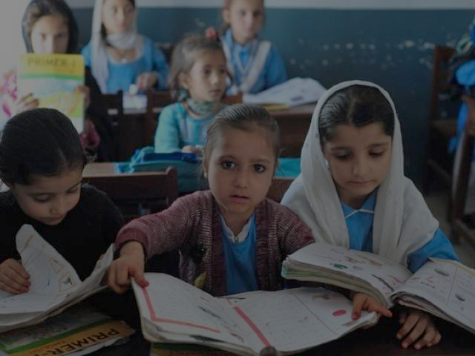

Home School Education Program
The goal of DAMEN’s social sector programs is to organize activities in the fields of education and primary health, primarily by mobilizing women caught in the cycle of enduring poverty. Through its home school education program, DAMEN seeks to empower poverty riven females by enabling them to start a non-formal home school and provide primary education to 5 to 14-year-old out-of-school children. DAMEN currently supports 100 such female-run home schools in Lahore, Sheikhupura, Kasur and Nankana Sahib, which provide primary education to around 4,000 children and thus keeps them off the streets and affords them a chance to educate, learn, and, hopefully, transition into productive citizens. Attached is the home school report for the last quarter, January-March 2019:
Home School Detail
SO Name | Boys | Girls | Total Students | Total schools
Amna Imtiaz | 241 | 249 | 490 | 13
Sakina Amir | 180 | 224 | 404 | 13
Sub Total | 421 | 473 | 894 | 26
Nargis Rehman | 231 | 277 | 508 | 15
Sub Total | 231 | 277 | 508 | 15
Shabnam Batool | 209 | 209 | 418 | 14
Sub Total | 209 | 209 | 418 | 14
Nasrin Jamshaid | 292 | 322 | 614 | 14
Sadia Saeed | 288 | 284 | 572 | 14
Sub Total | 580 | 606 | 1186 | 28
Shabila Yaqoob | 186 | 251 | 437 | 13
Sub Total | 186 | 251 | 437 | 13
Grand Total | 1,627 | 1,816 | 3,443 | 96

CASE STORY
Home School Teacher

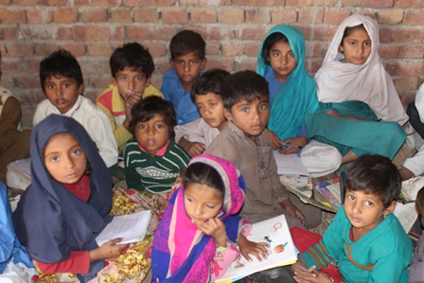
Teacher: Asma Abdullah
Age: 22 Years
Education: B.A
Marital Status: Unmarried

Asma Abdullah has joined DAMEN as a home school teacher in 2018. She belongs to lower middle class family. She is very enthusiastic and hardworking. As many as 40 students receive education at the school from class one to class five. After school, some students work to help their families financially. Her father owns a small shop but supported his daughter to get proper education. She has completed her graduation degree privately. Students and nearby communities are very satisfied with her work. It’s her ambition to get higher education and uplift the status and quality of her school in near future.

Health Care Services
DAMEN’s health centers run on similar lines as its educational program, founded on the principle of empowering local women to develop their communities and bring about positive and sustainable social change. Our 15 Lady Health Visitors (LHVs) not only provide medical treatment through their clinics and camps, they also conduct awareness campaigns on various health related issues such as family planning, maternal and child healthcare, and healthy lifestyle practices.
HEALTH CENTER VISITS
Area 1 (District Lahore)
So Name | No of Health Center | No of Patients
Sakina Amir | 1 | 109
Amna Imtiaz | 2 | 207
Total | 3 | 316
Area 2 (District Lahore)
Nargis Rehman | 2 | 324
Total | 2 | 324
Area 3 (District Sheikhupura)
Shabnam Batool | 1 | 170
Total | 1 | 170
Area 4 (District Kasur)
Nasreen Jamshaid | 2 | 284
Total | 2 | 284
Area 5 (District Nankana )
Shabila Yaqoob | 4 | 520
Total | 4 | 520
Grand Total | 12 | 1,614

CASE STORY
Lady Health Visitor

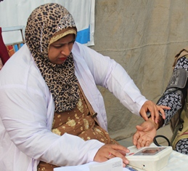
Sumera Bibi has been working as an LHV for the past 10 years. She started working with DAMEN from August 2018 and provided medical services to women and children in her village area during the evenings when other health facilities were unavailable. She has two children. Her husband works in a company. She belongs to poor class family. She contacted DAMEN so that she can open a health center. DAMEN helped her in running a health center. Now she treats poor people at minimal price. Now she is able to run her family properly. Samera Bibi is very grateful to the DAMEN for this opportunity.

Health Camps
Health camps are regularly set up in Lahore, Sheikhupura, Kasur, and Nankana Sahib by mobilizing LHVs to reach out to a greater number of patients. These health camps provide diagnostic and medical services at a modest PKR 10 per patient contribution, and many of our LHVs do not even charge this amount. These camps are set up in various locations such as DAMEN’s area offices and home schools. A wide variety of diseases and medical conditions are treated at these camps such as fever, aches and pains, diarrhea, blood pressure, gynecology and pregnancy related issues among others. In addition, awareness about family planning and contraceptives is also provided at these camps.
The following tables of DAMEN health camps on regular bases by Social Organizers during January-March 2019:

Area 1 (District Lahore)
So Name | No of Health Center | No of Patients
Sakina Amir | 2 | 64
Amna Imtiaz | 3 | 117
Total | 5 | 181
Area 2 (District Lahore)
Nargis Rehman | 2 | 100
Total | 2 | 100
Area 4 (District Kasur)
Nasreen Jamshaid | 2 | 62
Total | 2 | 62
Area 5 (District Nankana )
Shabila Yaqoob | 3 | 154
Total | 3 | 154
Grand Total | 12 | 497

Signed a MOU in-between DAMEN and Damen Support Programme (DSP) for a year 2019, according to this signed MOU DAMEN will arrange 4 Medical Camps in a month in DSP operational areas for good relationship in between DSP and operational communities, in these camps DAMEN provide free checkup and free medicines for needy peoples specially for women and children’s through DAMEN Lady Health Visitor (LHV). So in this regard DAMEN arranged 12 medical camps in this quarter January-March 2019 and received good response to community side.

The following tables of DSP health camps arrange by DAMEN during January-March 2019:
Free Medical Camps
Sr. # | Date | Area Name | Patients
 | 10 Jan 2019 | Nun, Rachna Town | 149
 | 16 Jan2019 | Ali Tibba, Rachna Town | 50
 | 23 Jan 2019 | Kalar, Rachna Town | 81
 | 30 Jan 2019 | Shamke, Rachna Town | 97
 | 6 Feb 2019 | Shahzad Town, Kot Abdul Malik | 96
 | 12 Feb 2019 | Masjid wali pully, Qilla Sattar Shah | 108
 | 19 Feb 2019 | Zia Abad, Sheikhupura | 68
 | 26 Feb 2019 | Mansoorabad, Sheikhupura | 109
 | 5 March 2019 | Qilla Sattar Shah | 95
 | 12 March 2019 | Khatikan Virkan | 97
 | 19 March 2019 | Rehmat Pura | 101
 | 26 March 2019 | Kot Hanif | 62
Total | Jan – March 2019 | Sheikhupura | 1,113

Reflections of Medical Camps
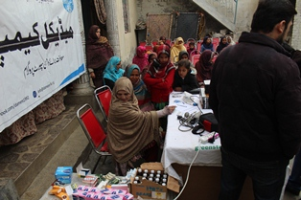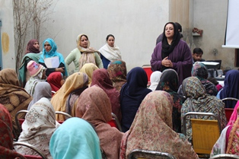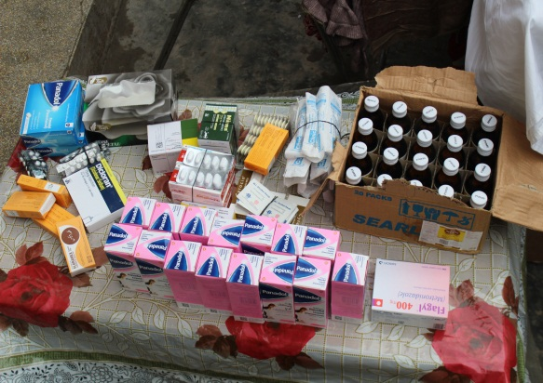
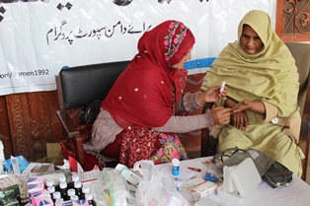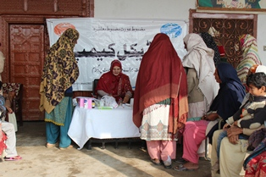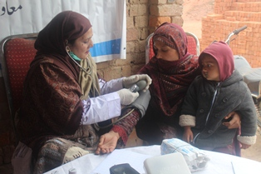
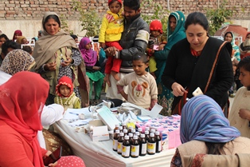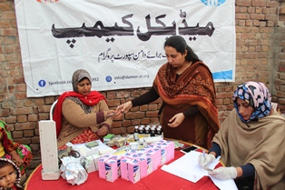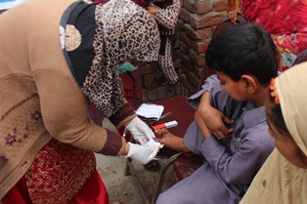

Training and Capacity Building

Empirical evidence suggests that capacity building plays an important role in the growth and expansion of communities and organizations. DAMEN therefore places a great deal of importance on the training and capacity building of its staff and the local community in which it carries out its operations.
Community Level
Community capacity building deals with supporting people to develop their skills and use them to raise awareness about social issues and consequently bring about positive change in society. DAMEN’s vision and mission are also based on this principle of self-empowerment and active social participation. Community capacity building is primarily achieved by holding regular Women Social Organization (WSO) meetings.
Institutional level
DAMEN also creates opportunities for its employees to grow and develop their skills, competencies and expertise so as to enable them to contribute to their self-development and the development of the community. The following are some training activities with staff members carried out during this quarter:
- Teachers training on LED uses in a DAMEN home school for better learning
- Teachers training on MISchool for “ how can they make students records for school and their parents”
Orientation of New Staff
Orientation sessions for newly hired staff were organized and gave a brief introduction of DAMEN and its policies and role in economic development. The orientation also briefed the new recruits about the code of conduct, social mobilization techniques and the policies and procedures followed by the social sector.

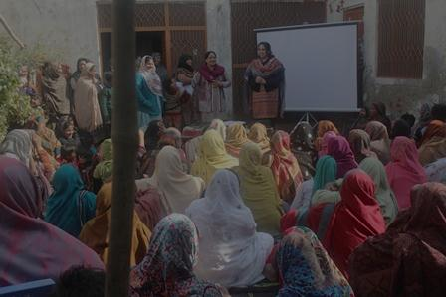

Women Social Organizations (WSO)
Each of the 96 DAMEN home schools supports an associated parental group called Women Social Organization (WSO) which comprises neighborhood women who gather on a regular basis to discuss community problems and engage with home school teachers, social organizers and the team leader to gain awareness about various issues dealing with education, health, environment and gender discrimination etc.
This year DAMEN and Damen Support Programme (DSP) signed a MOU that the DAMEN social sector will organized 12 WSO meetings for exposure about DSP working in their operational area to raise awareness among local residents about the issue of loan defaulters.
The following tables summarize the total number of WSO meetings held during this quarter January to March 2019:
WSO Meetings Arrange by DAMEN
Sr. # | Date | Area Name | No of participants
1. | 24 January 19 | Shamke | 42
2. | 29 January 19 | Nun | 63
3. | 13 February 19 | Ali Tibba | 40
4. | 27 February 19 | Kalar | 43
5. | 13 March 19 | Qilla Sattar Shah | 52
6. | 27 March 19 | Mansoorabad | 53
Total | 1st Quarter 2019 | Sheikhupura | 293

WSO Meetings with Social Organizers
Area 1 (District Lahore)
SO Name | No. of Members |  |  |  | No. of Meetings
Sakina Amir | 390 |  |  | 39
Amna Khalid | 390 |  |  | 39
Sub Total | 780 |  |  | 78
Area 2 (District Lahore)
Nargis Rehman | 450 |  |  | 45
Sub Total | 450 |  |  | 45
Area 3 (District Sheikhupura)
with the reference of signed MOU in-between DAMEN & DSP
Shabnam Batool |  | 293 |  | 6
Sub Total |  | 293 |  | 6
Area 4 (District Kasur)
Nasreen Jamshed |  |  | 728 | 30
Sadia Saeed |  |  | 670 | 41
Sub Total |  |  | 1,398 | 71
Area 5 (District Nankana)
Shabila Arther |  |  | 390 | 39
Sub Total |  |  | 390 | 39
Grand Total |  |  | 3,311 | 239

Networking and Linkages
DAMEN places great emphasis on building relationships with local and global actors to achieve its goals of poverty eradication and community development. In this regard a number of associations were established during this quarter to form linkages and networks with various institutions to generate mutually beneficial ties. Some of these are:

- DAMEN staff attended the International Women Day 8th March function that arranged by Damen Support Programme.

- Center for Economic Research in Pakistan has designed new software termed as “MISchool”. CERP gave software to our five selected schools for one month free trial period. Teachers were trained so they can learn how to operate software. MISchool software helped DAMEN in checking the status of School.

- DAMEN has organized 12 Medical Camps and 6 WSOs with collaboration with DSP.

1st Floor, 187 Excise & Taxation Employees Cooperative Housing Society, Abdul Sattar Edhi Road, Lahore
Ph No: +92 (42) 35452500
www.damen-pk.org info@damen-pk.org

