- Oct-Dec 2018  Quarterly Report  Quarter Overview:  - 3,470 Students Enrolled in 100 Home Schools  - 5,917 Patients Visited 15 Health Centers  - 669 Patients Visited 16 LHV Health Camps  - 109 Women Attended 6 Women Social Organization (WSO) Meetings Conducted by Training Coordinator  - 1,060 Women Attended 100 WSO Meetings Conducted by Social Organizers on Community Issues |  | Home School Education Program  Health Care Services  Training and Capacity Building  Networking and Linkages  DAMEN  1st Floor, 187 Excise & Taxation Employees Cooperative Housing Society, Abdul Sattar Edhi Road, Lahore  www.damen-pk.org  info@damen-pk.org  Ph No:+92 (42) 35452500

Table of Contents

Executive Summary 3
Home School Education Program 4
Health Care Services 6
Health Camps 6
Training and Capacity Building 8
Women Social Organizations (WSO) 9
Networking & Linkages 10

Executive Summary

This quarterly report refers to the period from October to December 2018. It has been a rather eventful quarter for us. We networked extensively with partners, in the very beginning; we faced two Everest like challenges – improving service delivery in general and stagnant funds.
To do that, we crafted a classy strategy to deal with it. This means that we go back to the drawing board, pull up all the previous blueprints and come up with a forward-looking framework that could spell out the challenge, its resolution and its benefit. We were pleasantly surprised with our findings.
We revised our core staff’s job descriptions, more focused towards purpose of task rather than activities and decided that, from here on, we will delegate outcomes rather than activities. We also defined program indicators for a clearer output. This practically changed the whole eco-system of our management practices and we started to see new horizons. Our creative muscles started to pump harder and lo and behold we saw results raining down upon us.
A quick round up of some new activities that we make in this Quarter as follows:
- Exclusive Health Camp and Medicine Donation with REKO Pharmacal Lahore
- Merchandise gift donated by UMT Management and Schools of Business and Economics students.
- DAMEN has signed a MOU with Damen Support Program (DSP) for a one-year term.
DAMEN has stagnant revenue streams since a very long time. This is attributed largely by the change in the funding landscape of the country and the stated position of the donors, who are now more inclined to partner as peers with their implementing partners. This is a huge shift. Nevertheless, it is difficult but not impossible.
This report gives an overview of the activities carried out by DAMEN during the period October 1, 2018 to December 31, 2018 and is intended to provide relevant and updated information regarding our ongoing and new initiatives to our stakeholders and potential supporters.
We appreciate your continued cooperation and support.
Nabila Roohi
Team Leader
Social Sector
nabila.roohi@damen-pk.org

Home School Education Program

The goal of DAMEN’s social sector programs is to organize activities in the fields of education and primary health, primarily by mobilizing women caught in the cycle of enduring poverty. Through its home school education program, DAMEN seeks to empower poverty riven females by enabling them to start a non-formal home school and provide primary education to 5 to 14-year-old out-of-school children. DAMEN currently supports 100 such female-run home schools in Lahore, Sheikhupura, Kasur, Okara and Nankana Sahib, which provide primary education to around 4,000 children and thus keeps them off the streets and affords them a chance to educate, learn, and, hopefully, transition into productive citizens. Attached is the home school report for the last quarter, October-December 2018:
Area 1 (District Lahore)
SO Name | Boys | Girls | Total Students | Total schools
Sakina Amir | 179 | 230 | 409 | 14
Amna Imtiaz | 246 | 236 | 482 | 14
Sub Total | 425 | 466 | 891 | 28
Area 2 (District Lahore)
Nargis Rehman | 233 | 258 | 491 | 15
Sub Total | 233 | 258 | 491 | 15
Area 3 (District Sheikhupura)
Shabnam Batool | 217 | 228 | 445 | 15
Sub Total | 217 | 228 | 445 | 15
Area 4 (District Kasur)
Nasreen Jamshed | 290 | 325 | 615 | 14
Sadia Saeed | 282 | 290 | 572 | 14
Sub Total | 572 | 615 | 1,187 | 28
Area 5 (District Nankana)
Razia Bano | 192 | 264 | 456 | 14
Sub Total | 192 | 264 | 456 | 14
Grand Total | 1,632 | 1,831 | 3,470 | 100

CASE STORY
Home School Teacher

Shumaila Yaqoob, 37 years old with twelve years of education, lives in Chung along with her family which includes her in-laws, husband and children. Her husband is a factory worker, and her in-laws are farmer.
She is working with DAMEN as a teacher since April 2018 and has received different trainings and according to her theses trainings have proved to be very advantageous for her in order to improve the quality of her teaching techniques. Shumaila is very hard work lady and doing all efforts for the sake of supporting her husband and family to minimize the financial burden and wants to make her life very successful.
Her aim to give the high and good education to her home school students she is very thankful to DAMEN for support of free books and furniture etc.
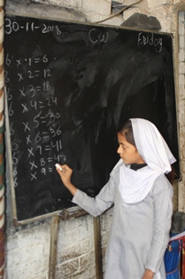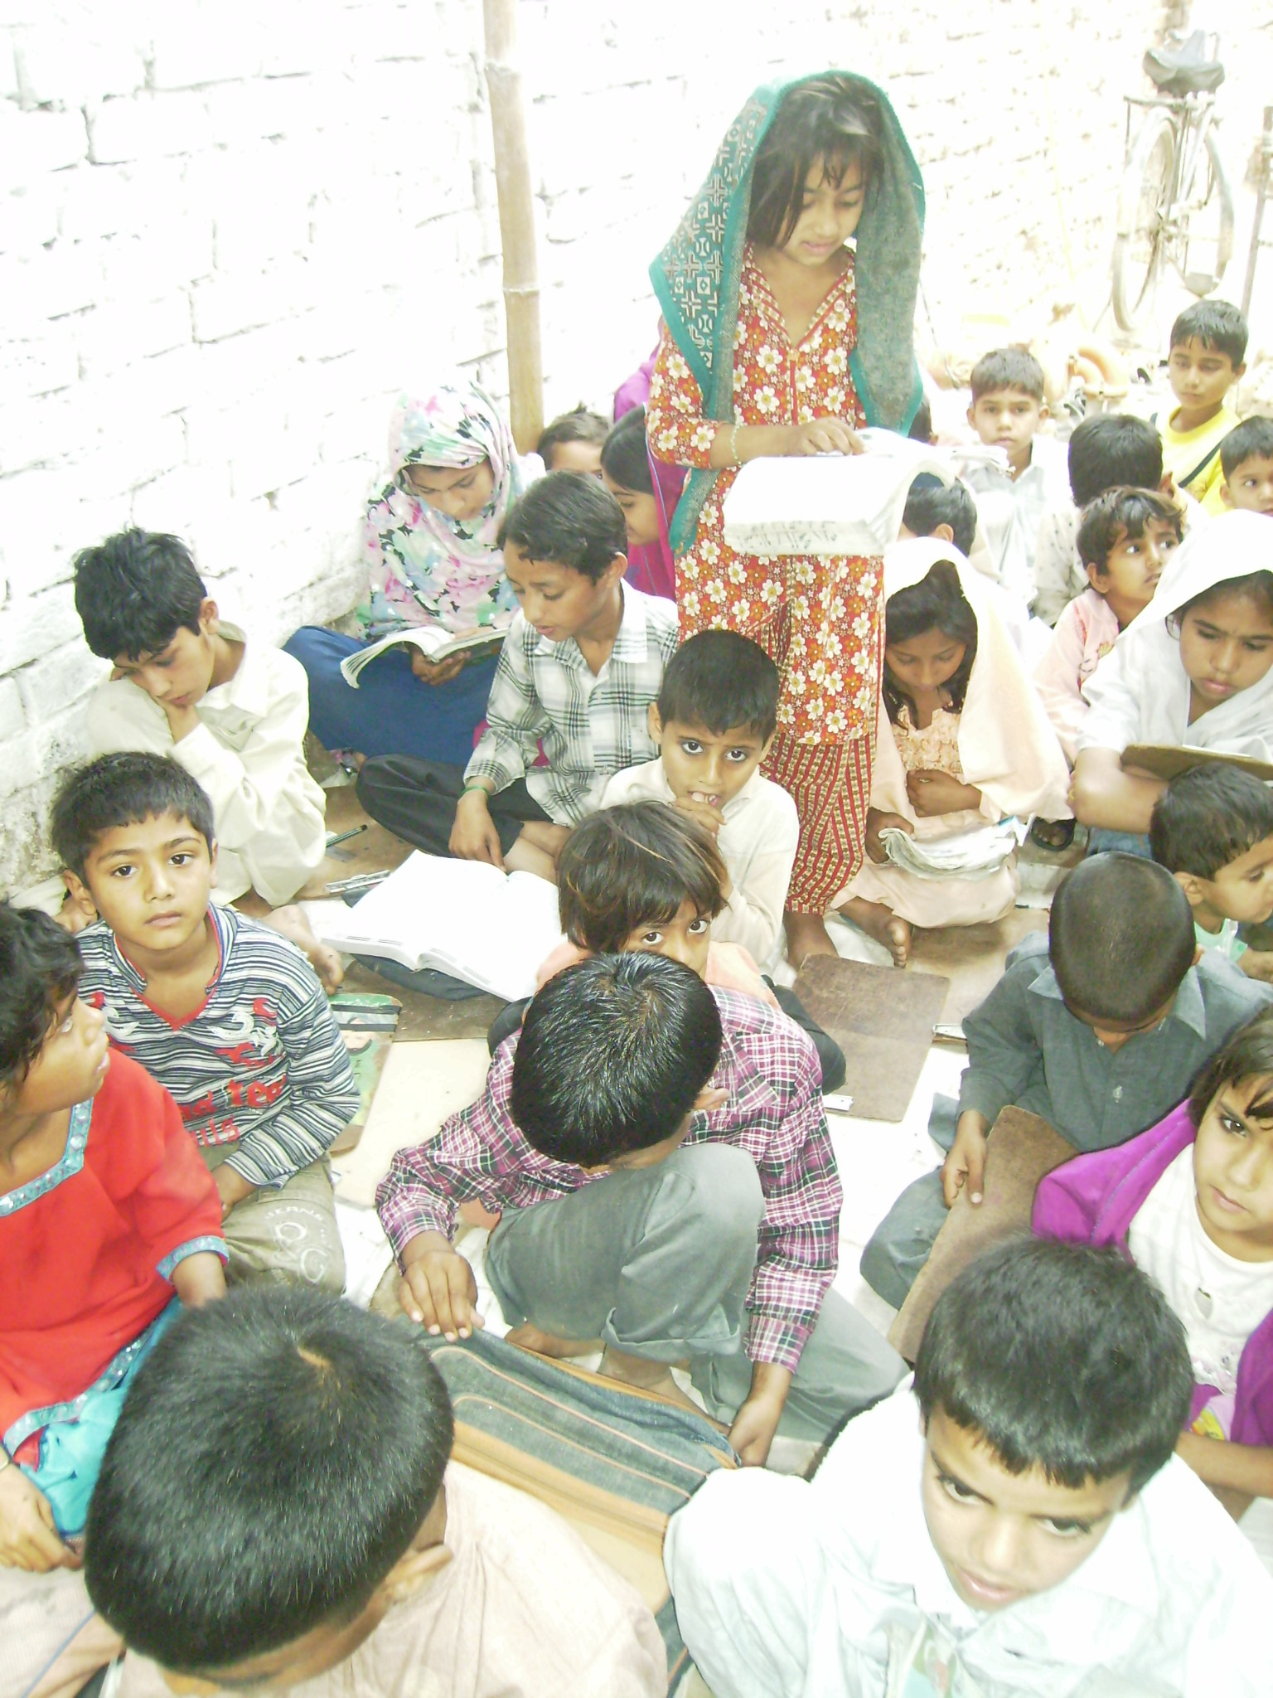

Health Care Services

DAMEN’s health centers run on similar lines as its educational program, founded on the principle of empowering local women to develop their communities and bring about positive and sustainable social change. Our 15 Lady Health Visitors (LHVs) not only provide medical treatment through their clinics and camps, they also conduct awareness campaigns on various health related issues such as family planning, maternal and child healthcare, and healthy lifestyle practices.
LHV Story
Ms. Mumtaz bibi is running a health center im pattoki, Kasur since April 2017. She provides basic and maternal health care to over a hundred patients every month, primarily women and children. She runs her clinic from 3-5 pm and charges a fee of PKR 10 per patient. She not only supplements her household income but also invests in her school going children’s education.

Health Camps
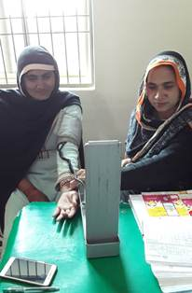
Health camps are regularly set up in Lahore, Sheikhupura, Kasur, Okara and Nankana Sahib by mobilizing LHVs to reach out to a greater number of patients. These health camps provide diagnostic and medical services at a modest PKR 10 per patient contribution, and many of our LHVs do not even charge this amount. These camps are set up in various locations such as DAMEN’s area offices and home schools. A wide variety of diseases and medical conditions are treated at these camps such as fever, aches and pains, diarrhea, blood pressure, gynecology and pregnancy related issues among others. In addition, awareness about family planning and contraceptives is also provided at these camps.
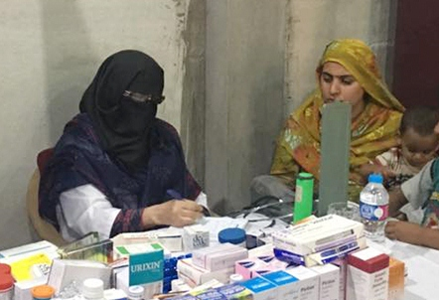

The following tables summarize the outreach of the health care services offered by DAMEN during October-December 2018:

HEALTH CENTER VISITS
Area 1 (District Lahore)
SO Name | No. of Health Center | No. of Patients
Sakina Amir | 1 | 324
 | 1 | 263
Amna Imtiaz | 1 | 383
 | 1 | 389
Total | 4 | 1,359
Area 2 (District Lahore)
Nargis Rehman | 1 | 408
 | 1 | 370
Total | 2 | 778
Area 3 (District Sheikhupura)
Shabnam Batool | 1 | 470
 | 1 | 470
Total | 2 | 940
Area 4 (District Kasur)
Nasreen Jamshed | 1 | 457
 | 1 | 447
Sadia Saeed | 1 | 445
Total | 3 | 1,349
Area 5 (District Nankana)
Shabila Arther | 1 | 359
 | 1 | 385
 | 1 | 405
 | 1 | 342
Total | 4 | 1,491
Grand Total | 15 | 5,917

HEALTH CAMP VISITS
Areas | No. of Health Camps | Total No of Patients
Area 1 | 4 | 153
Area 2 | 2 | 97
Area 3 | 2 | 87
Area 4 | 4 | 138
Area 5 | 4 | 194
Grand Total | 16 | 669

Training and Capacity Building

Empirical evidence suggests that capacity building plays an important role in the growth and expansion of communities and organizations. DAMEN therefore places a great deal of importance on the training and capacity building of its staff and the local community in which it carries out its operations.
Community Level
Community capacity building deals with supporting people to develop their skills and use them to raise awareness about social issues and consequently bring about positive change in society. DAMEN’s vision and mission are also based on this principle of self-empowerment and active social participation. Community capacity building is primarily achieved by holding regular Women Social Organization (WSO) meetings.
Institutional Level
DAMEN also creates opportunities for its employees to grow and develop their skills, competencies and expertise so as to enable them to contribute to their self-development and the development of the community. The following are some training activities carried out during this quarter:

- Teacher training workshops were held in Lahore, Kasur, Sheikhupura and Nankana Sahib for DAMEN’s Home School Teachers on Teaching Skills

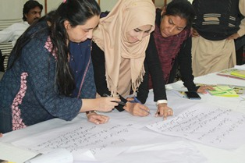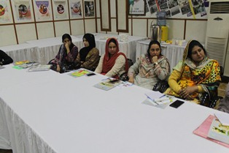
Orientation of New Staff
Orientation sessions for newly hired staff were organized and gave a brief introduction of DAMEN and its policies and role in economic development. The orientation also briefed the new recruits about the code of conduct, social mobilization techniques and the policies and procedures followed by the social sector

Women Social Organizations (WSO)
Each of the DAMEN home schools supports an associated parental group called Women Social Organization (WSO) which comprises neighborhood women who gather on a regular basis to discuss community problems and engage with home school teachers, social organizers and the training coordinator to gain awareness about various issues dealing with education, health, and environment.
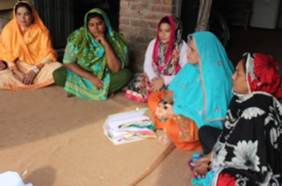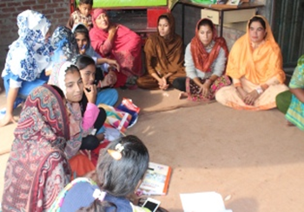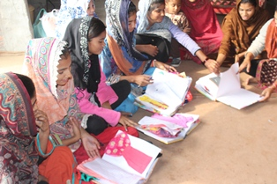
The following tables summarize the total number of WSO meetings held during this quarter:
WSO Meetings with Social Organizers
Area 1 (District Lahore)
SO Name | No. of Members |  |  |  |  |  | No. of Meetings
 | Oct |  |  | Nov | Dec |  | Oct | Nov | Dec
Sakina Amir | 143 |  |  | 157 | 140 |  | 13 | 14 | 14
Amna Khalid | 119 |  |  | 147 | 142 |  | 13 | 14 | 14
Sub Total | 262 |  |  | 304 | 282 |  | 26 | 28 | 28
Area 2 (District Lahore)
Nargis Rehman | 140 |  |  | 150 | 150 |  | 14 | 15 | 15
Sub Total | 150 |  |  | 150 | 150 |  | 14 | 15 | 15
Area 3 (District Lahore)
Shabnam Batool |  | 120 |  | 120 | 150 | 12 |  | 14 | 15
Sub Total |  | 120 |  | 120 | 150 | 12 |  | 14 | 15
Area 4 (District Lahore)
Nasreen Jamshed |  |  | 151 | 169 | 171 |  | 12 | 14 | 14
Sadia Saeed |  |  | 151 | 158 | 167 |  | 11 | 14 | 14
Sub Total |  |  | 302 | 327 | 338 |  | 23 | 28 | 28
Area 5 (District Lahore)
Shabila Arther |  |  | 1170 | 162 | 140 |  | 17 | 15 | 14
Sub Total |  |  | 170 | 162 | 140 |  | 17 | 15 | 14
Grand Total |  |  | 1,004 | 1,063 | 1,060 |  | 92 | 100 | 100

WSO Meetings with Training Coordinator
Dates | Venue | Participants
19th Non | Shamke Bhattian - II | 18
20th Nov | Juliana - II | 15
26th Nov | Harban da Daira - III | 15
27th Nov | Muridke - III | 16
11th Dec | Pattoki - IV | 25
12th Dec | Choonian - IV | 20

These meetings aim to sensitize local communities on issues of gender and also to create a formal structure consisting of designations, roles and responsibilities for local women for effective community mobilization and project execution.

Networking & Linkages

The following collaboration events took place during this quarter:

- DAMEN has submitted a proposal with British Council for Engagement with Youths (Girls and Boys). It is volunteer training program for one year to motivate parents through volunteers to increase the enrolment level of their local children in schools.

- UMT students deposited warm clothes merchandise for distribution to deserving people. DAMEN has distributed the donated merchandise its Lahore Area-1

- DAMEN organized Health Camp at Barkat Pura, Lahore Area-1. Awareness session lead by LHV, Ms. Saeeda, REKO Pharmacal, donated free drugs valued around Rs. 20,000. Local women were extremely happy and appreciated DAMEN’s effort, while desiring for more such camps.

- MPhil Students of LUMS School of Education visited DAMEN schools in Area-1 to collect teacher data for their practicum notes

- DAMEN signed an MOU with Damen Support Program (DSP) for one year to conduct 48 Medical Camps and 24 WSO meetings in DSP designated areas.

Glimpses of networking and linkages:

UMT Donation

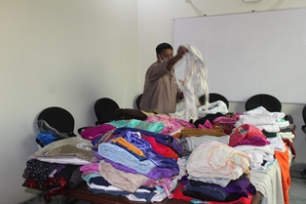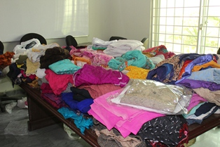

Medical camp donation by REKO Pharmacal

