- Apr-June 2018  Quarterly Report  Quarter Overview:  - 3,402 Students Enrolled in 86 Home Schools  - 5,157 Patients Visited 14 Health Centers  - 425 Patients Visited 11 LHV Health Camps  - 63 Teachers Attended Training Workshops in Areas 1, 2, 3, 4 and 5 on interactive training session  - 12 Community based projects include tree plantation projects, environmental cleanliness drives, stitching and beautician training courses. This is a result of revamping our WSOs. |  | Home School Education Program  Health Care Services  Training and Capacity Building  Networking and Linkages  DAMEN  26-C, Nawab Town, Raiwind Road, Lahore  www.damen-pk.org  info@damen-pk.org  Phone: 042-35232615

Table of Contents

Executive Summary 3
Home School Education Program 4
Health Care Services 6
Health Camps 6
Training and Capacity Building 8
Women Social Organizations (WSO) 9
Networking & Linkages 11

Executive Summary

This quarterly report refers to the period from April to June 2018. It has been a rather eventful quarter for us. We networked extensively with partners, in the very beginning; we faced two Everest like challenges – improving service delivery in general and stagnant funds.
To do that, we crafted a classy strategy to deal with it. This means that we go back to the drawing board, pull up all the previous blueprints and come up with a forward-looking framework that could spell out the challenge, its resolution and its benefit. We were pleasantly surprised with our findings.
We revised our core staff’s job descriptions, more focused towards purpose of task rather than activities and decided that, from here on, we will delegate outcomes rather than activities. We also defined program indicators for a clearer output. This practically changed the whole eco-system of our management practices and we started to see new horizons. Our creative muscles started to pump harder and lo and behold we saw results raining down upon us.
A quick round up of some new program implementation methods stand as follows:
- Our Women Social Organizations were restructured through the introduction of roles and responsibilities for community women
- The concept of School Management Committees was introduced to have a hawk eye on our home-based schools by the local community and much more…
DAMEN has stagnant revenue streams since a very long time. This is attributed largely by the change in the funding landscape of the country and the stated position of the donors, who are now more inclined to partner as peers with their implementing partners. This is a huge shift. Nevertheless, it is difficult but not impossible. We sat down and came up with an actionable strategy to reach out to corporate for-profit institutions, who are more aligned with our vision and mission. We think when we shook hands with McDonald’s (SIZA Foods and GLAM Corporations, local license holders in Pakistan) we found them forthcoming and a good addition for generating CSR based funds from for-profit companies in Pakistan. Let’s see how it rolls out.
We would be absolutely delighted to speak more on it if you have the time to listen to the chapters of our day to day progress. Have a good day!
Nabila Roohi
Team Leader
Social Sector
nabila.roohi@damen-pk.org

Home School Education Program

The goal of DAMEN’s social sector programs is to organize activities in the fields of education and primary health, primarily by mobilizing women caught in the cycle of enduring poverty. Through its home school education program, DAMEN seeks to empower poverty riven females by enabling them to start a non-formal home school and provide primary education to 5 to 14-year-old out-of-school children. DAMEN currently supports 86 such female-run home schools in Lahore, Sheikhupura, Kasur, Okara and Nankana Sahib, which provide primary education to around 4,000 children and thus keeps them off the streets and affords them a chance to educate, learn, and, hopefully, transition into productive citizens. Attached is the home school report for the last quarter, April-June 2018:
Area 1 (District Lahore)
SO Name | Boys | Girls | Total Students | Total schools
Sakina Amir | 240 | 223 | 463 | 14
Robina Begum | 334 | 290 | 624 | 14
Sub Total | 574 | 513 | 1,087 | 28
Area 2 (District Lahore)
Nargis Rehman | 224 | 238 | 462 | 14
Sub Total | 224 | 238 | 462 | 14
Area 3 (District Sheikhupura)
Shabnam Batool | 195 | 193 | 388 | 10
Sub Total | 195 | 193 | 388 | 10
Area 4 (District Kasur)
Nasreen Jamshed | 251 | 258 | 509 | 8
Sadia Saeed | 238 | 211 | 449 | 10
Sub Total | 489 | 469 | 958 | 18
Area 5 (District Nankana)
Razia Bano | 150 | 177 | 327 | 11
 | 91 | 89 | 180 | 5
Sub Total | 241 | 266 | 507 | 16
Grand Total | 1,723 | 1,679 | 3,402 | 86

CASE STORY
Home School Teacher
Saiqa, 25 years old young girl with ten years of education, lives in Niaz Baig along with her family which includes her parents, two sisters and one brother. Her father is a factory employee.
She is engaged with DAMEN from the last two years and has received different trainings and according to her theses trainings have proved to be very advantageous for her in order to improve the quality of her teaching techniques. Saiqa is doing all efforts for the sake of supporting her father to minimize his financial burden and wants to excel in her career.
Her aim to give a high raise to her home school and for this she need more support from DAMEN such as free books, school bags and stationary etc.
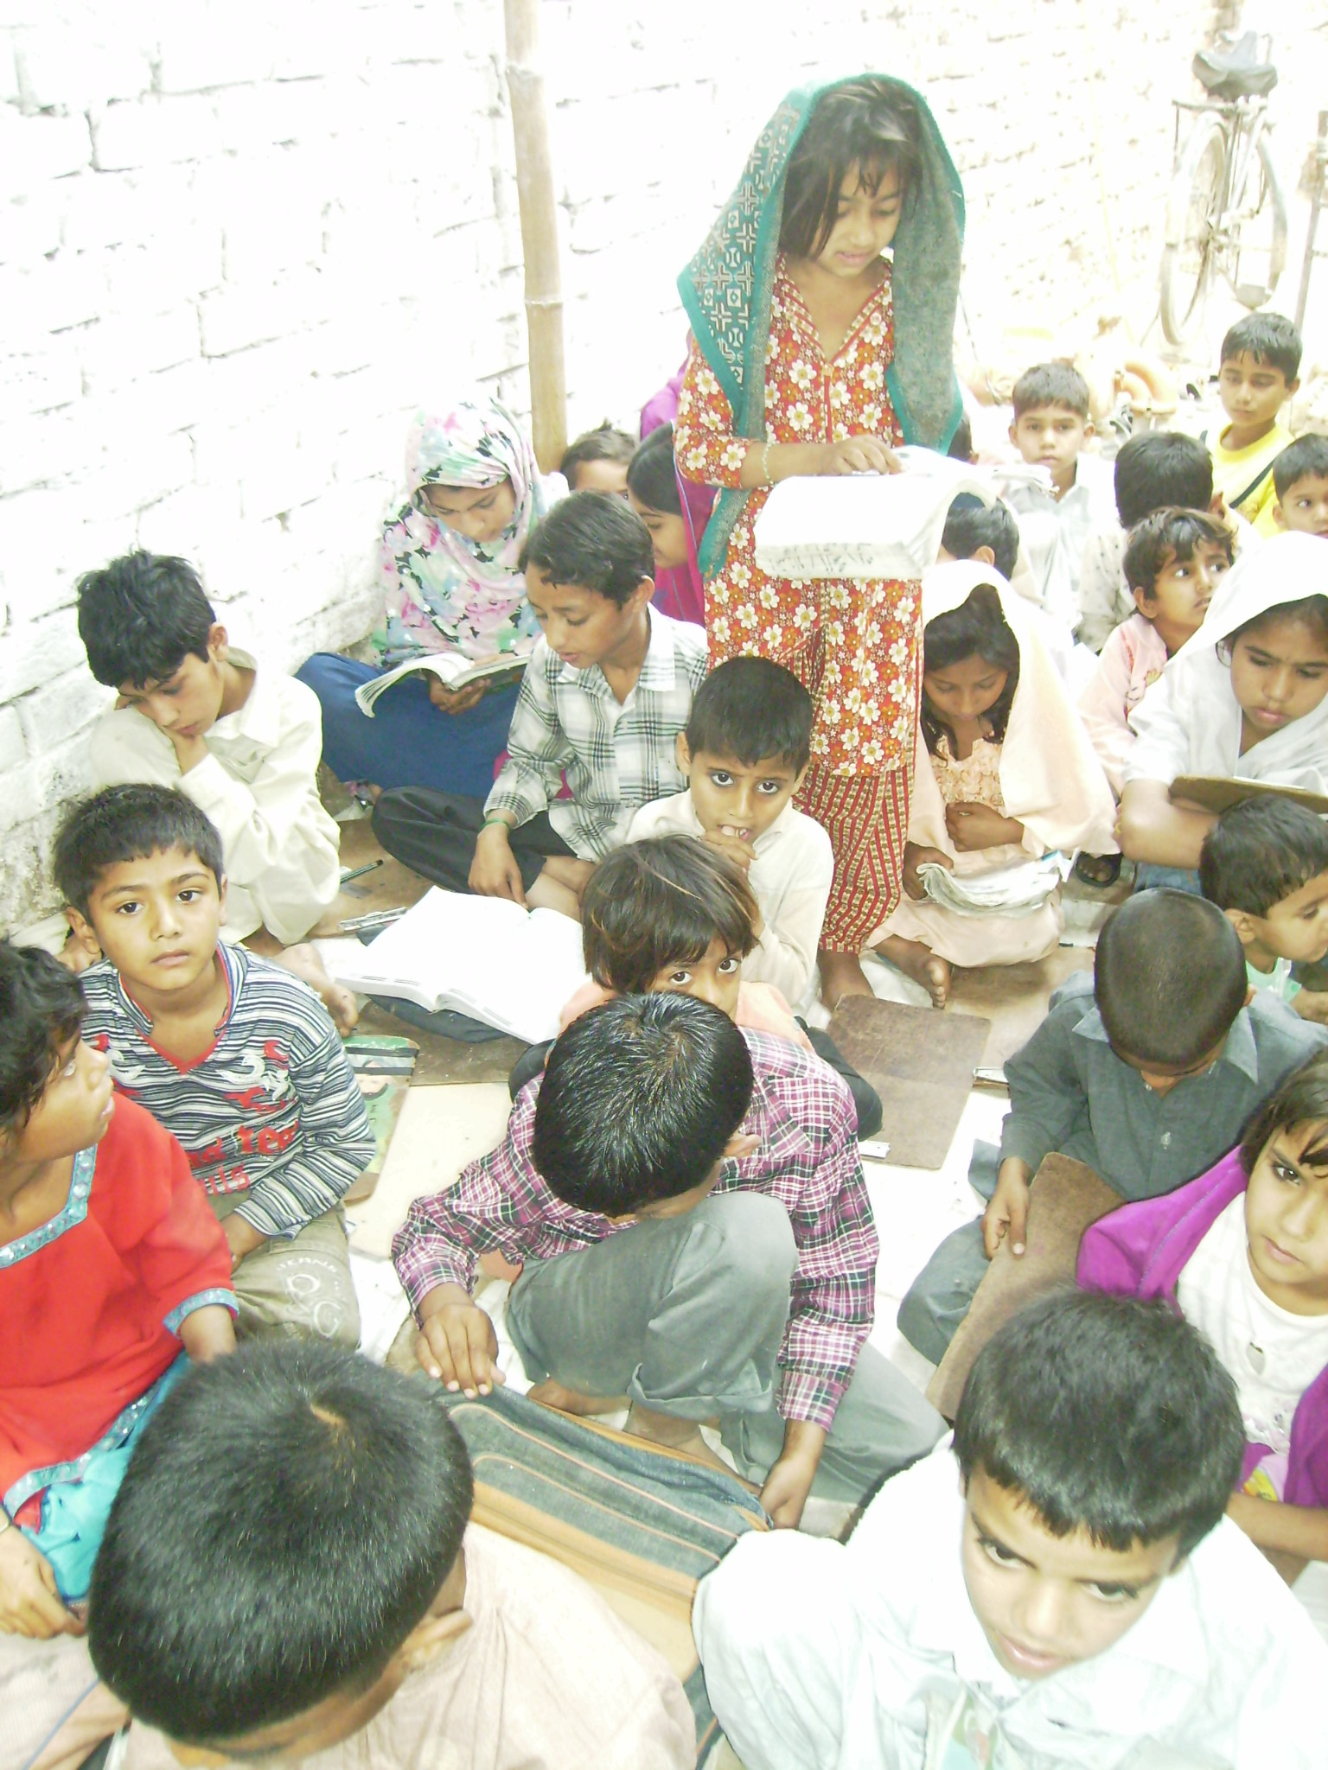

Health Care Services

DAMEN’s health centers run on similar lines as its educational program, founded on the principle of empowering local women to develop their communities and bring about positive and sustainable social change. Our 15 Lady Health Visitors (LHVs) not only provide medical treatment through their clinics and camps, they also conduct awareness campaigns on various health related issues such as family planning, maternal and child healthcare, and healthy lifestyle practices.
LHV Story
Ms. Sharifan Maryam is running a health center on arayian Pind, Lahore since October 2016. She provides basic and maternal health care to over a hundred patients every month, primarily women and children. She runs her clinic from 2-5 pm and charges a fee of PKR 10 per patient. She not only supplements her household income but also invests in her colllege going children’s education.
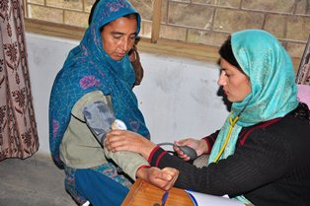

Health Camps
Health camps are regularly set up in Lahore, Sheikhupura, Kasur, Okara and Nankana Sahib by mobilizing LHVs to reach out to a greater number of patients. These health camps provide diagnostic and medical services at a modest PKR 10 per patient contribution, and many of our LHVs do not even charge this amount. These camps are set up in various locations such as DAMEN’s area offices and home schools. A wide variety of diseases and medical conditions are treated at these camps such as fever, aches and pains, diarrhea, blood pressure, gynecology and pregnancy related issues among others. In addition, awareness about family planning and contraceptives is also provided at these camps.
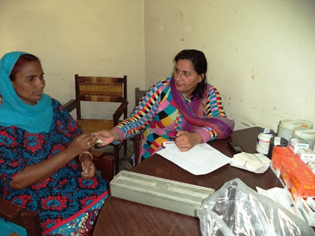

The following tables summarize the outreach of the health care services offered by DAMEN during April-June 2018:

HEALTH CENTER VISITS
Area 1 (District Lahore)
SO Name | No. of Health Center | No. of Patients
Sakina Amir | 1 | 343
 | 1 | 325
Robina Begum | 1 | 312
 | 1 | 365
Total | 4 | 1,345
Area 2 (District Lahore)
Nargis Rehman | 1 | 170
 | 1 | 528
Total | 2 | 698
Area 3 (District Sheikhupura)
Shabnam Batool | 1 | 540
Total | 1 | 540
Area 4 (District Kasur)
Nasreen Jamshed | 1 | 435
 | 1 | 430
Sadia Saeed | 1 | 405
Total | 3 | 1,270
Area 5 (District Nankana)
Razia Bano | 1 | 319
 | 1 | 385
 | 1 | 290
 | 1 | 310
Total | 4 | 1,304
Grand Total | 14 | 5,157

HEALTH CAMP VISITS
Areas | No. of Health Camps | Total No of Patients
Area 1 | 3 | 125
Area 2 | 1 | 40
Area 3 | 1 | 32
Area 4 | 2 | 56
Area 5 | 4 | 172
Grand Total | 11 | 425

Training and Capacity Building

Empirical evidence suggests that capacity building plays an important role in the growth and expansion of communities and organizations. DAMEN therefore places a great deal of importance on the training and capacity building of its staff and the local community in which it carries out its operations.
Community Level
Community capacity building deals with supporting people to develop their skills and use them to raise awareness about social issues and consequently bring about positive change in society. DAMEN’s vision and mission are also based on this principle of self-empowerment and active social participation. Community capacity building is primarily achieved by holding regular Women Social Organization (WSO) meetings.
Institutional Level
DAMEN also creates opportunities for its employees to grow and develop their skills, competencies and expertise so as to enable them to contribute to their self-development and the development of the community. The following are some training activities carried out during this quarter:

- 5 two-day teacher training workshops were held in Lahore, Kasur, Sheikhupura and Nankana Sahib for DAMEN’s Home School Teachers on WSO’s Community Base Project

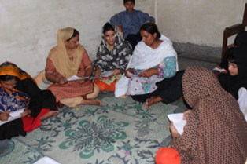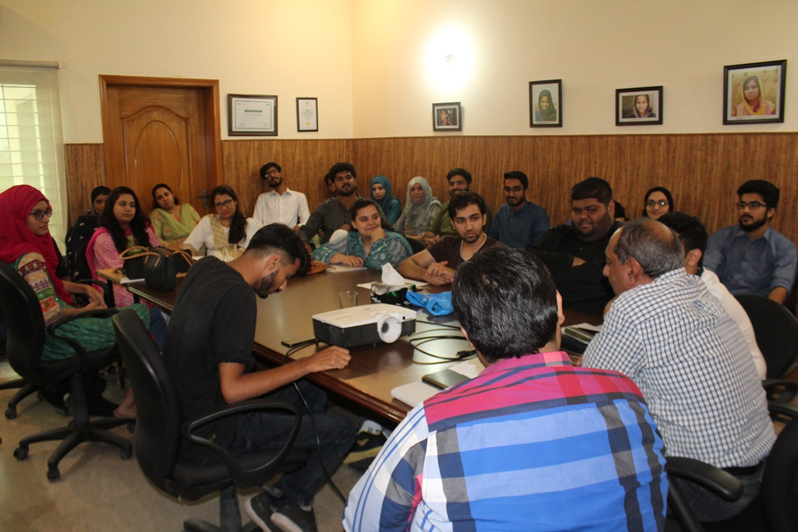

Orientation of New Staff
Orientation sessions for newly hired staff were organized and gave a brief introduction of DAMEN and its policies and role in economic development. The orientation also briefed the new recruits about the code of conduct, social mobilization techniques and the policies and procedures followed by the social sector

Women Social Organizations (WSO)
Each of the DAMEN home schools supports an associated parental group called Women Social Organization (WSO) which comprises neighborhood women who gather on a regular basis to discuss community problems and engage with home school teachers, social organizers and the training coordinator to gain awareness about various issues dealing with education, health, and environment.
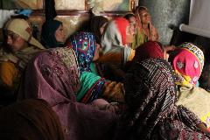
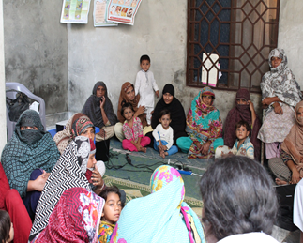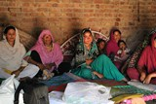
The following revamped structure of WSO and meeting on it during this quarter:

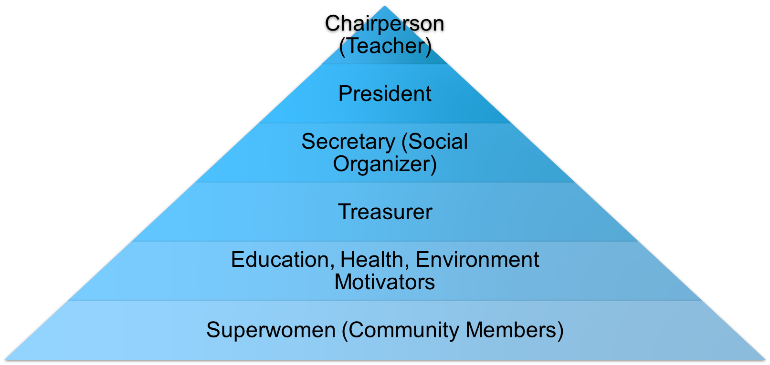

WSO Meetings for Community Based Project with Social Organizers
Sr.# | S.O. Name | District Name | Chairperson (Teacher) Name | School Address/Location | Area of Focus
1. | Sakina Amir | Area 1 | Amina Yaqoob | Amina park Hunjarwal Lahore | Environment  (Plantation)
2. | Nargis Rehman | Area 2 | Noreen | Manga Mandi | Environment  (Plantation)
3. | Nargis Rehman | Area 2 | Noreen | Manga Mandi | Environment  (Plantation)
4. | Nargis Rehman | Area 2 | Sumaira Sharafat | Rangeel Pur | Stitching
5. | Shabnam Batool | Area 3 | Nabila Asif | Bilal park Muridke | Stitching
6. | Shabnam Batool | Area 3 | Sukaina | Sardar colony Muridke | Stitching
7. | Shabnam Batool | Area 3 | Sukaina Rasheed | Sardar Colony | Stitching
8. | Nasrin Sharif | Area 4 | Shumaila Khalil | Bhoay Asil | CNIC Card
9. | Sadia Saeed | Area 4 | Tuba Shabir | Bonga Balochan Phool nager | CNIC Card
10. | Nasrin Sharif | Area 4 | Yousra Shabir | Jumber Khurd | Beautician
11. | Sadia Saeed | Area 4 | Shumaila Arshed | Phool Nagar Liaqat Town | Stitching
12. | Razia Bano | Area 5 | Yasmin G Alam | Main road, Ashraf Abad Mangtanwala More Khunda | Stitching
13. | Razia Bano | Area 5 | Victoria Shamoon | Youngsonabad , Johar k pass | Stitching
14. | Razia Bano | Area 5 | Victoria Shamoon | Youngsonabad | Stitching
15 | Razia Bano | Area 5 | Victoria Shamoon | Johar k pass | Beautician

These meetings aim to sensitize local communities on issues of gender and also to create a formal structure consisting of designations, roles and responsibilities for local women for effective community mobilization and project execution.

Networking & Linkages

The following collaboration events took place during this quarter:

- School Management Committees Engaged in distribution of Textbook donation by Packages Foundation

- School Management Committees Engaged in distribution of Furniture to Damen Home Schools donation by Love Letter event/ donation by Ms. Zareen Niazi and Ms. Salma Rashid

- All Home Schools and Health Centers Reports Converted to Google Forms (Real Time Data Collection)

- Signed MoU with LUMS

- Engaged with 5 Management Interns who Assisted in Translation of Google Forms
